11. Applying databases normalization technique to eliminate redundancy and improve data integrity in workbench query.

create table students_course(
student_id int,
student_name varchar(50),
course_id int,
course_name varchar(50),
primary key(student_id,course_id)
);
insert into students_course values
(1,'gauri',203,'english'),
(2,'bhavana',204,'math'),
(3,'neha',205,'physics');
select*from students_course;
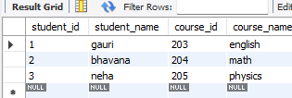

2: (Normalize to 1NF,2NF, and 3NF);
Create Students Table (Remove redundant student info)
create table students(
student_id int primary key,
student_name varchar(50)
);
insert into students(student_id,student_name)
select distinct student_id,student_name
from students_course;
select*from students;
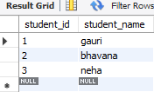

Create Courses Table (Remove redundant course info)
create table course(
course_id int primary key,
course_name varchar(50)
);
insert into course(course_id,course_name)
select distinct course_id,course_name
from students_course;

Create Enrollments Table (Mapping table between students and courses)
create table enrollment6(
student_id int,
course_id int,
primary key(student_id,course_id),
foreign key(student_id)references student(student_id),
foreign key(course_id)references course(course_id)
);
insert into enrollment6(student_id,course_id)
select student_id,course_id
from students_course;
select*from enrollment6;
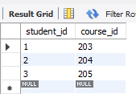

3: Test the normalized structure.(At a time execute this query)
select*from students;
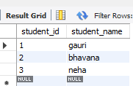
select*from course;
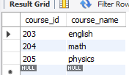
select*from enrollment6;
select c.course_name
from students s
join enrollement6 e on s.student_id=e.student_id
join course c on e.course_id=c.course_id
where s.student_name='bhavana';



